Explore Products

Deployment Manual:

1. Download Software Required:

|  |  |  |  |
| --- | --- | --- | --- |
| Software Name | Description | Version | Download Link |
| **Java** | Prog Language | 1.8 | [Java-1.8](https://javadl.oracle.com/webapps/download/AutoDL?BundleId=248737_8c876547113c4e4aab3c868e9e0ec572) |
| **Oracle** | Database | 11g | [Oracle-11g](https://dl.filehorse.com/win/developer-tools/oracle-database-express/OracleXE112_Win64.zip?st=rd8oF0ptNhigX0D-nYbeyg&e=1688643766&fn=OracleXE112_Win64.zip) |
| SQL Developer | SQL IDE | Latest | [SQL deloper-21.2](https://www.oracle.com/tools/downloads/sqldev-downloads-2120.html) |
| **Spring tool suite** | IDE | 4 | [Spring Tools-4.19](https://download.springsource.com/release/STS4/4.19.0.RELEASE/dist/e4.28/spring-tool-suite-4-4.19.0.RELEASE-e4.28.0-win32.win32.x86_64.self-extracting.jar) |
| **GitHub Desktop** | Git | Latest | [GitHub Desktop](https://central.github.com/deployments/desktop/desktop/latest/win32) |

*Note: Steps which are written in bold letter is mandatory to run project.*

1. Setup Java ([Video Link - Click](https://youtu.be/-O4QVijnA7Y))
   * **Install Java**
   * Set Path for java (Optional).
2. Add project in local workspace from GitHub.
   * **Using GitHub Desktop by Git Clone (Recommend).**
   * Using zip file.
3. Setup Database
   * **Install Oracle Database.  
     Note: Remember your username & password of oracle database which is created during installation.**
   * Install SQL Developer (optional).
   * Execute Db script in database (optional).
4. **Import project in IDE (Spring tool suite) from local folder.**
5. **Setup IDE (Spring tool suite) Environment.**
6. **Configure Database Properties.**
7. **Run Project.**

**Mandatory Steps in Detail:**

1. **Add project in local workspace from GitHub:**
   1. **Using GitHub Desktop by Git Clone (Recommend):**
      1. Install GitHub desktop.
      2. Create a folder called **workspace** in C: drive.
      3. Open GitHub desktop.
      4. Press ctrl+shift+o to open clone repository or   
         go to -> file -> clone repository
      5. Choose URL as shown in image.
      6. Then choose path where you want to clone the repository,  
         Or you can enter **C:\workspace** in Local path.
      7. Then enter Repository URL-  
          <https://github.com/ib321/Explore-Products.git>
      8. Then click on clone.

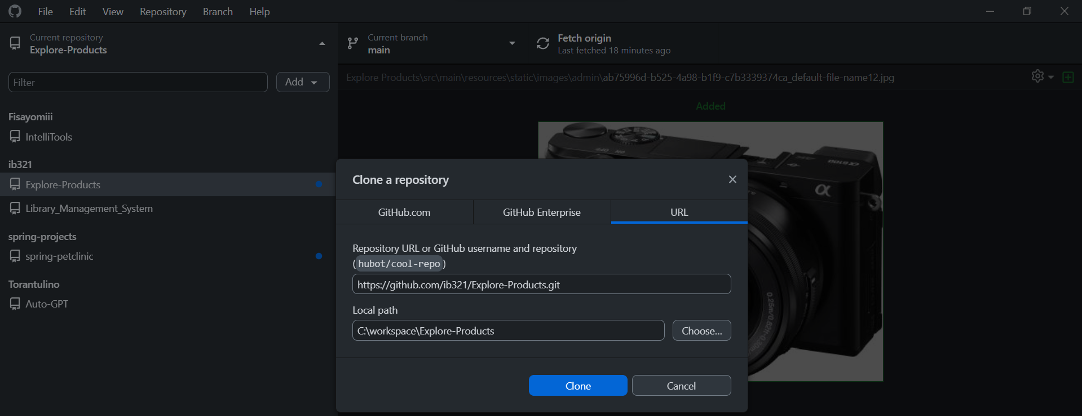

1. **Import project in IDE (Spring tool suite) from local folder:**
   1. Create a folder in C: Drive called **workspace**
   2. Open spring tool suite 4 & Enter **C:\workspace** as shown below then click Launch.

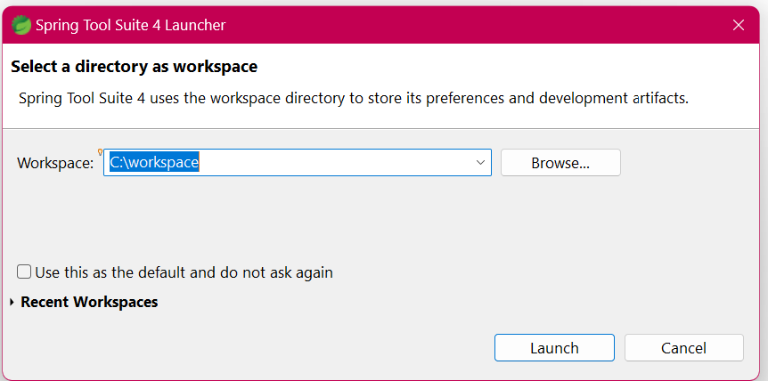

* 1. Click on **File -> Import…** & then **type maven and choose Existing Maven Projects** as shown below

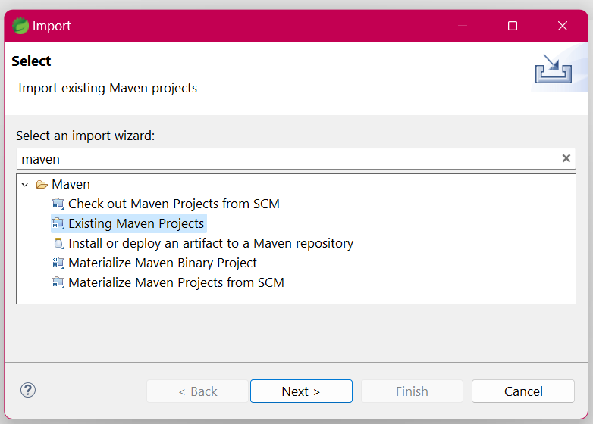

* 1. Click Next   
     click on Browse then go to root directory of project and then click on select folder   
     Or  
     just enter **C:\workspace\Explore-Products\Explore Products** in Root Directory
  2. 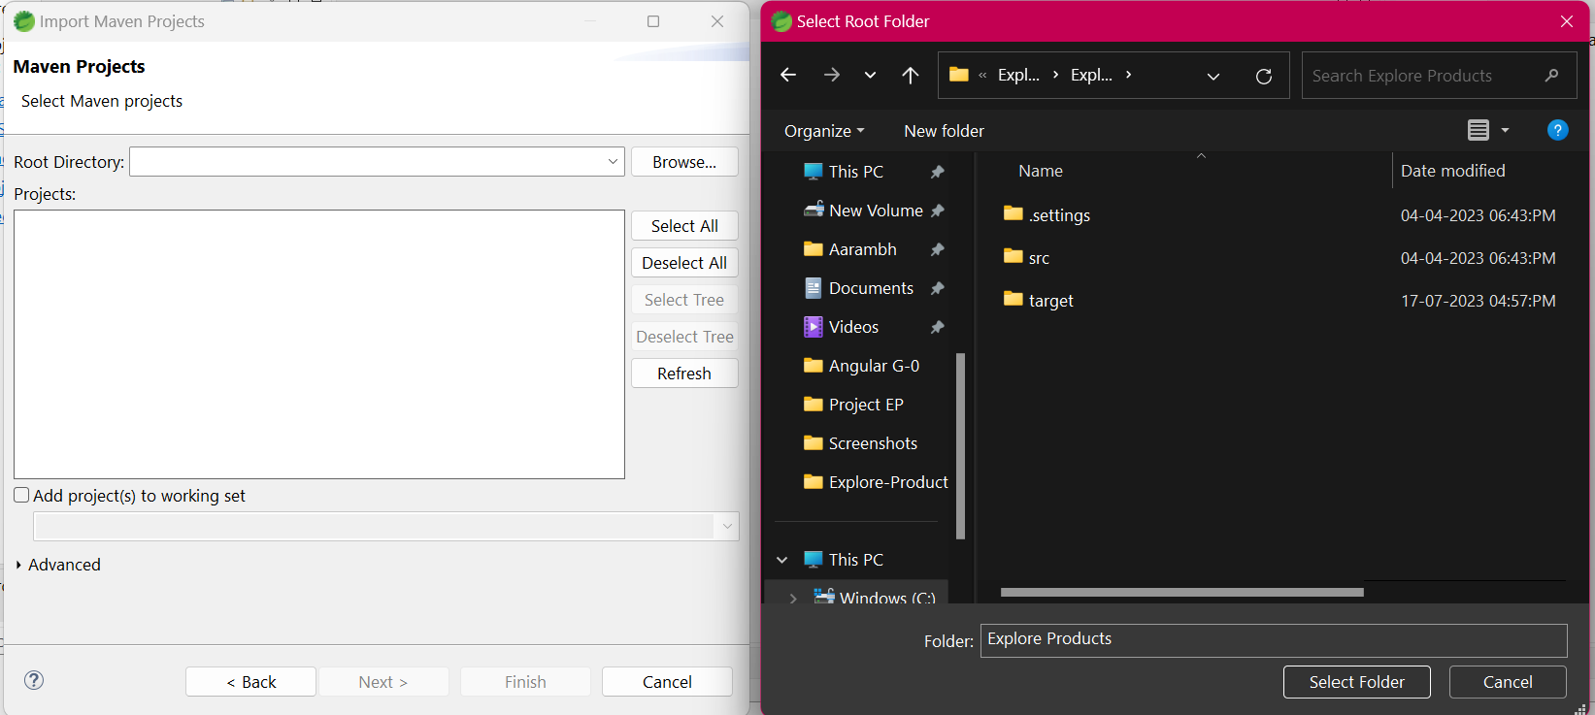You can find your root directory in the path where you have cloned this project.
  3. click on finish.
  4. Wait for some time spring tool suite will import maven project.
  5. Now do next step to setup the IDE environment before running the project.

1. **Setup IDE (Spring tool suite) Environment to Run Project:**

# We have to configure **Installed JREs** to setup Environment

1. **Installed JREs**
   1. Spring tool suite should be opened and project should be imported as done in previous step.
   2. 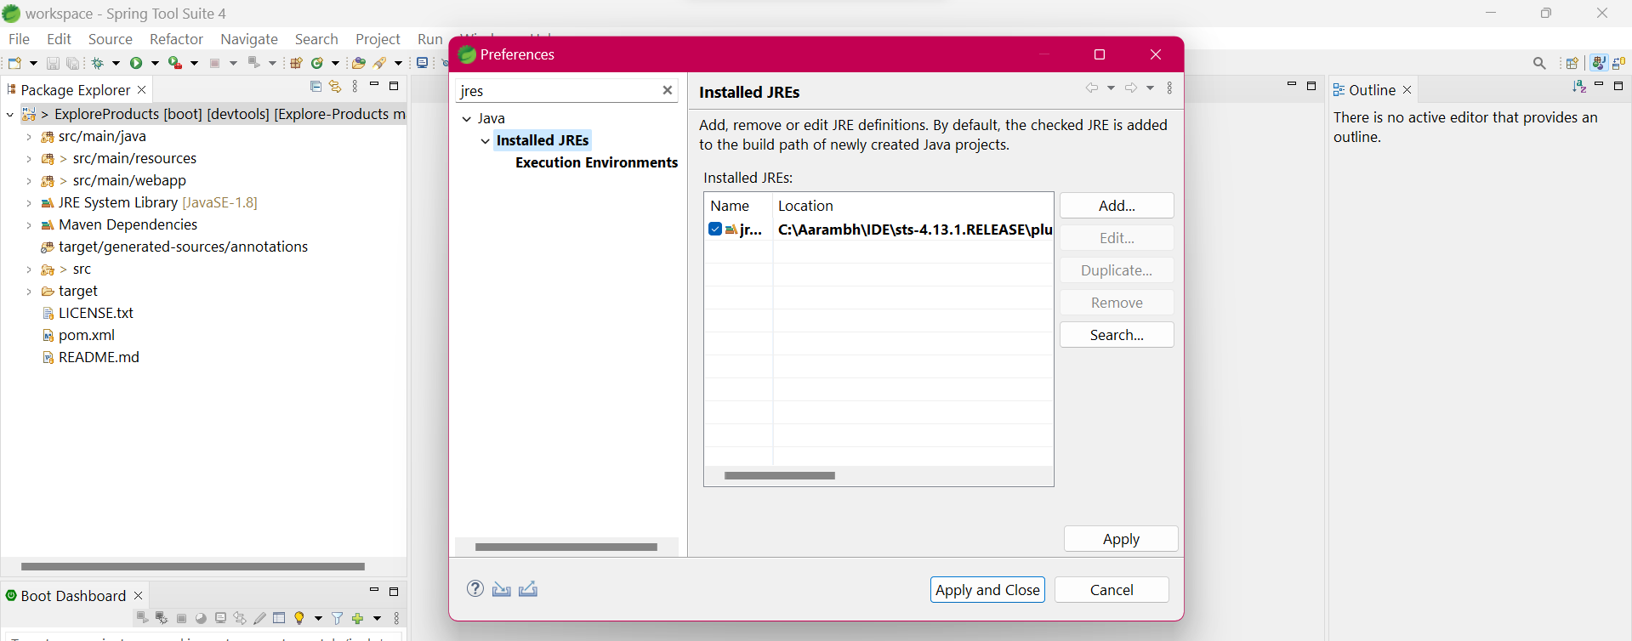Now Go to Windows -> Preferences
   3. Type jres then click on **Installed JREs** as shown in above diagram.
   4. Click on **Add** then on next pop up **click Next.**
   5. 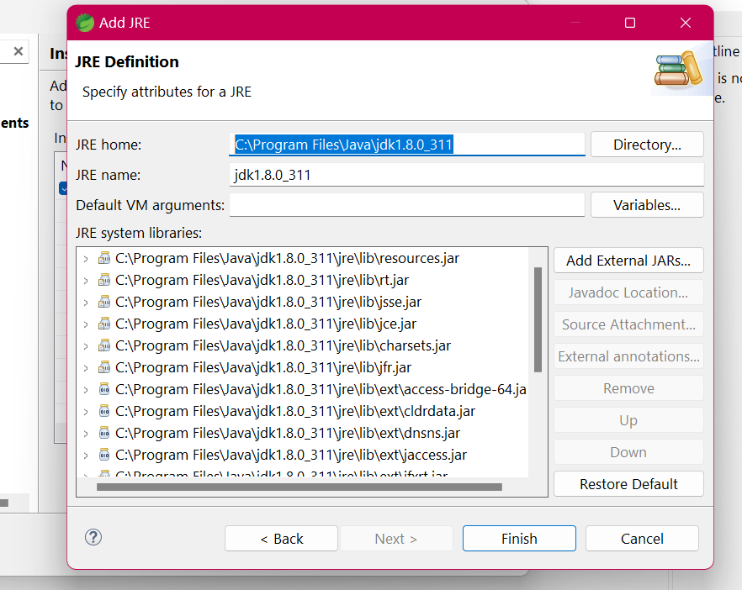Now enter **C:\Program Files\Java\jdk1.8.0_311** in JRE HOME Or you can also browse and select your Java JRE Home location.
   6. Now click on Finish.  
        
      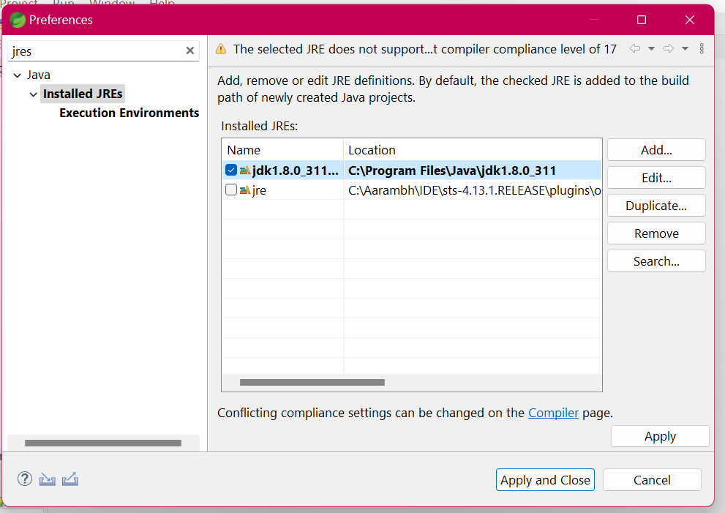
   7. Now click on **tick box of** **jdk1.8.0_311** like shown above   
      then click **Apply and Close**.

**7. Configure Database Properties:**

* configure the database connection properties
  + Open **application.properties** file located in the **src/main/resources** folder.
  + You need to specify the database URL, username, password, and driver class name.
* spring.datasource.url = jdbc:oracle:thin:@localhost:1521:xe
* spring.datasource.username = system
* spring.datasource.password = system
* spring.datasource.driver-class-name = oracle.jdbc.driver.OracleDriver

**8.Run Project:**

**Note: Above Mandatory Steps should have been followed and Java and Oracle Database is installed.**

1. 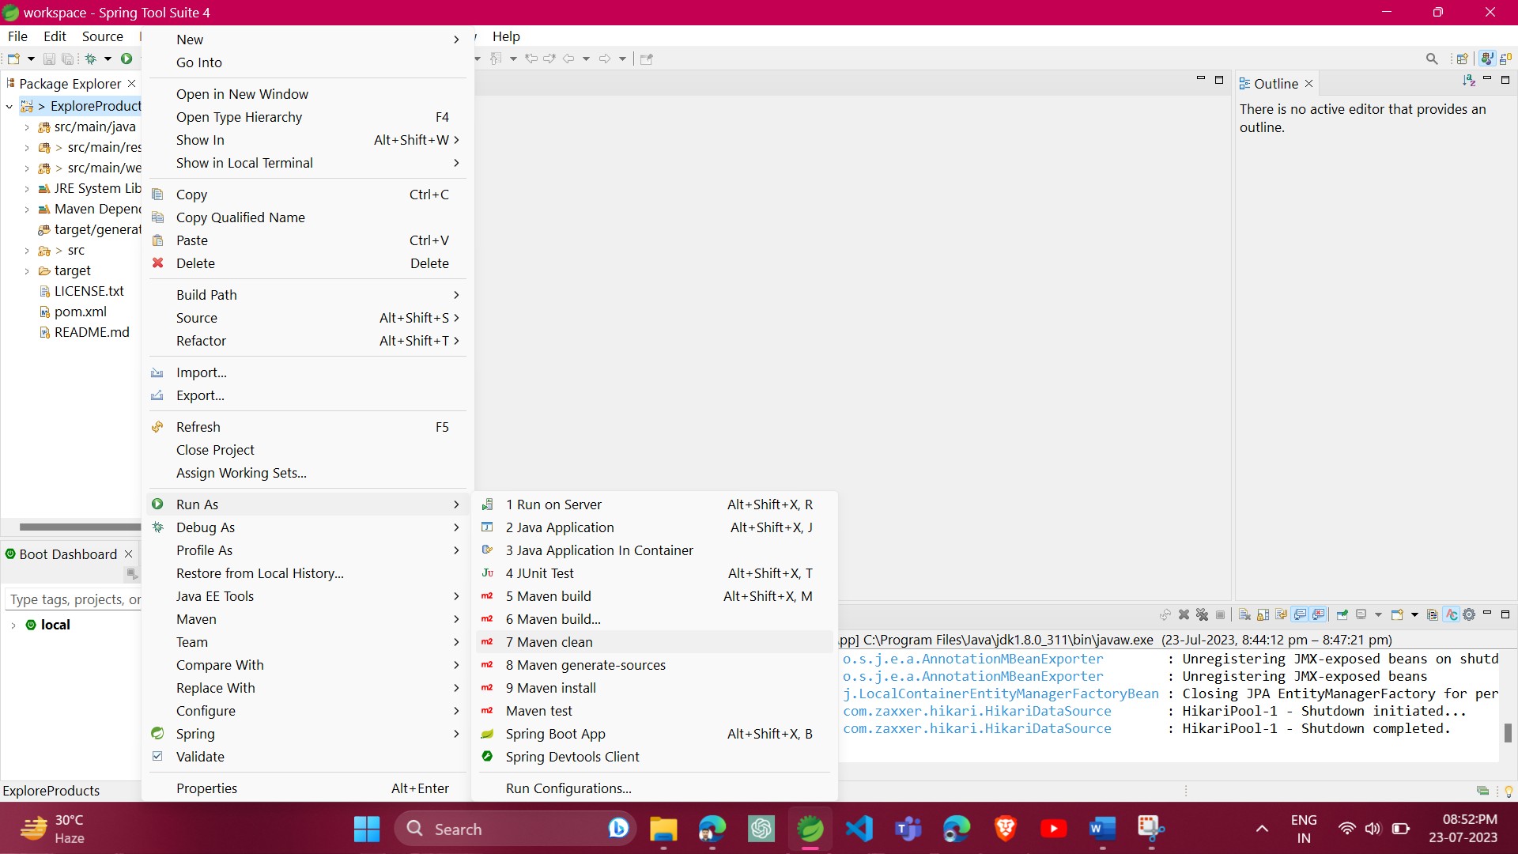Right click on project to open menus then **go to -> Run as -> Maven clean.**
2. Again Right click on project then **go to -> Run as -> Maven build.**
3. 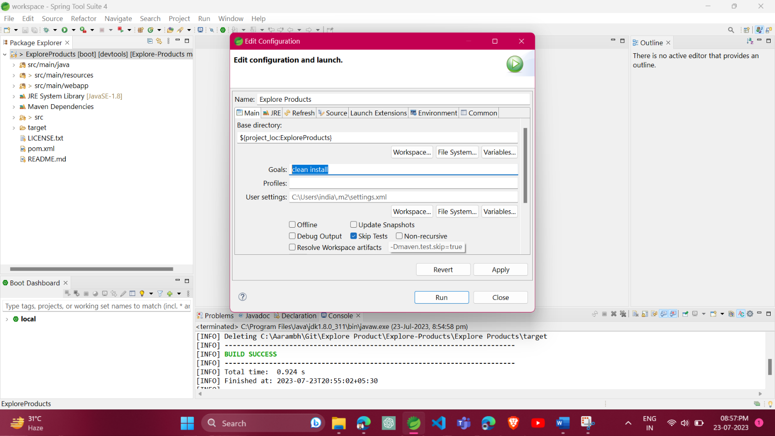Now one pop up will open as shown below  
   Enter **clean install** in **Goals.  
   Tick Skip Tests.**
4. Click Run to build project.
5. Once build is success.
6. Right click on project then **go to -> Run as -> Spring Boot App.**
7. Open Any browser and type **localhost:8098 to view project.**

Note: Default port of application is set to 8098.

You can change port by

* + Open **application.properties** file located in the **src/main/resources** folder.
  + Change **server.port = 8098.**
  + change 8098 into the port of your choice.